|  |  |  |
| --- | --- | --- |
| **Course Name:** Application of ICT lab | | |
| **LAB # 10**: Basics of Networking: Computers Vs Raspberry pi | | |
| **Department** | **Registration Number/Name** | **Semester/Section** |
| BS CEN | F24604018/Muhammad Hamzah Iqbal  F24604060/Tariq Khan  F24604043/Abdullah Waheed  F24604058/Abu Bakar  F24604030/Hassan Nisar  F24604035/Fahad Bhatti | 1 |
| **Date** | **Instructor’s Name** | **Instructor’s Signature** |
| 14/12/2024 | Iqra Ashraf |  |

**Objectives:**

* How to connect to Ethernet on PC
* How to test the Connectivity between the devices

**Introduction**

Networking is the backbone of modern communication, enabling devices to exchange information and resources efficiently. In this lab, we explore the basics of networking through practical applications like connecting devices and setting up an FTP (File Transfer Protocol) server. This lab serves as a guide to understanding how to create, configure, and use an FTP server for transferring files between computers, a fundamental task in computer networking.

An FTP server allows users to upload, download, and manage files on a remote server over a network. It’s widely used in industries to share large files securely, automate backups, and facilitate collaboration between teams.

**Lab Tasks**

* **Part 0: Connecting to Ethernet on PC**

In this step, we will physically connect your PC to a network using an Ethernet cable. This involves connecting one end of the cable to your computer and the other to a modem or router. Properly configuring the Ethernet connection ensures reliable communication between devices on the network.

* **Part 1: Installing the Windows FTP Server Software**

Next, we will enable the FTP server functionality on your Windows PC. This involves accessing the Windows Features menu and installing the necessary components, such as the FTP Service and Extensibility options. These tools are essential for hosting an FTP server on your computer.

* **Part 2: Creating an FTP Server**

This task involves setting up the FTP server by creating a designated folder for file sharing, configuring the server settings in the IIS Manager, and specifying the IP address. This step establishes the FTP server's foundation, enabling file transfer capabilities.

* **Part 3: Allowing FTP through the Windows Firewall**

In this step, we will configure your firewall settings to allow FTP traffic. By modifying the "Allowed Apps" settings, you ensure that the FTP server can communicate with other devices without being blocked by security restrictions.

* **Part 4: Connecting to the FTP Server**

Finally, you test the FTP server by accessing it from another computer. This involves using the server’s IP address to connect via a web browser or FTP client, logging in with the credentials, and transferring files to verify successful communication.

**Part 0:**[**Connecting to Ethernet on PC**](https://www.wikihow.com/Connect-to-Ethernet-on-PC-or-Mac)

1. Connect your modem to the internet cord
2. Connect your modem to the router
3. Check to make sure your modem/router is online.
4. 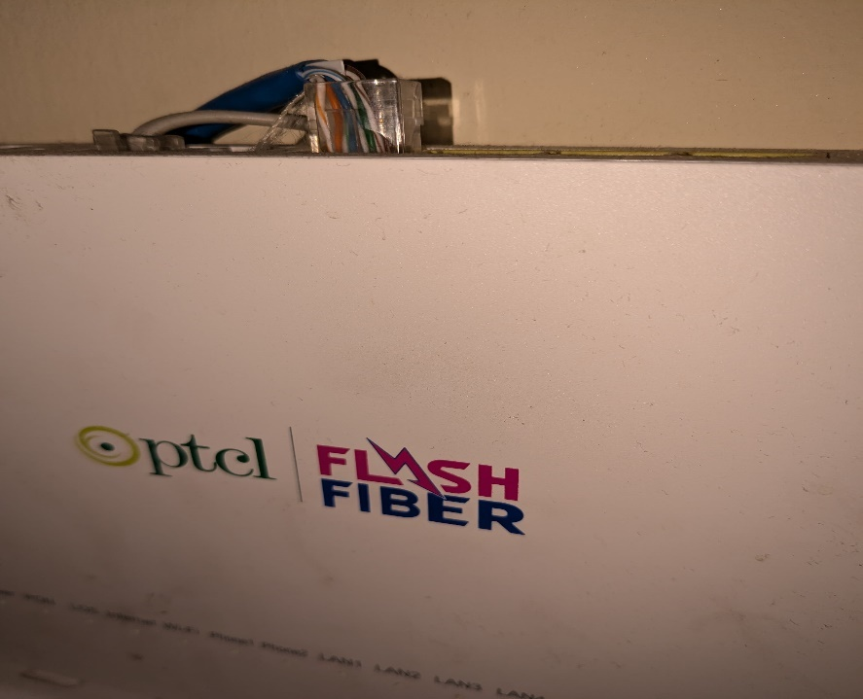Connect an Ethernet cable to the modem/router.
5. Connect the other end of the Ethernet cable to your computer.

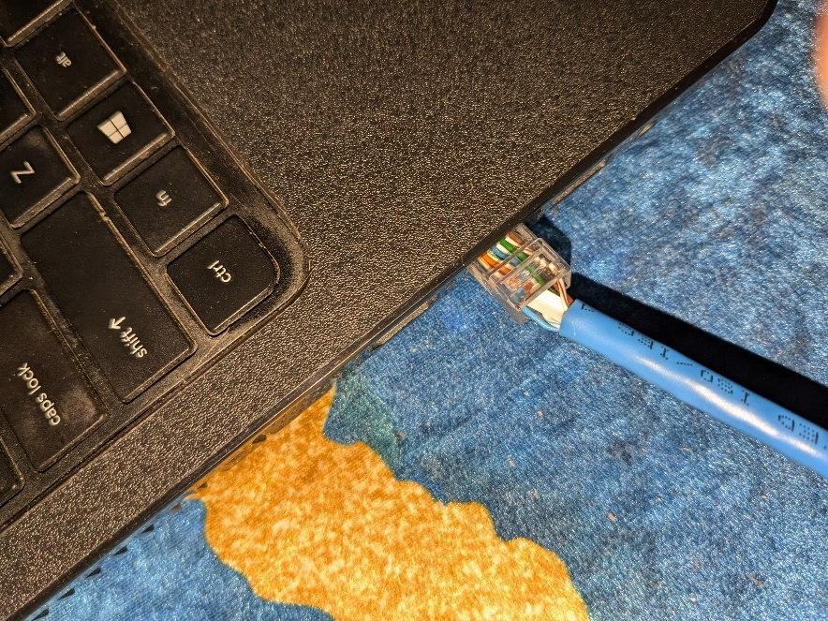

1. Click the Windows Start menu.
2. Click the settings icon.
3. Click the "Network & Internet" icon.
4. 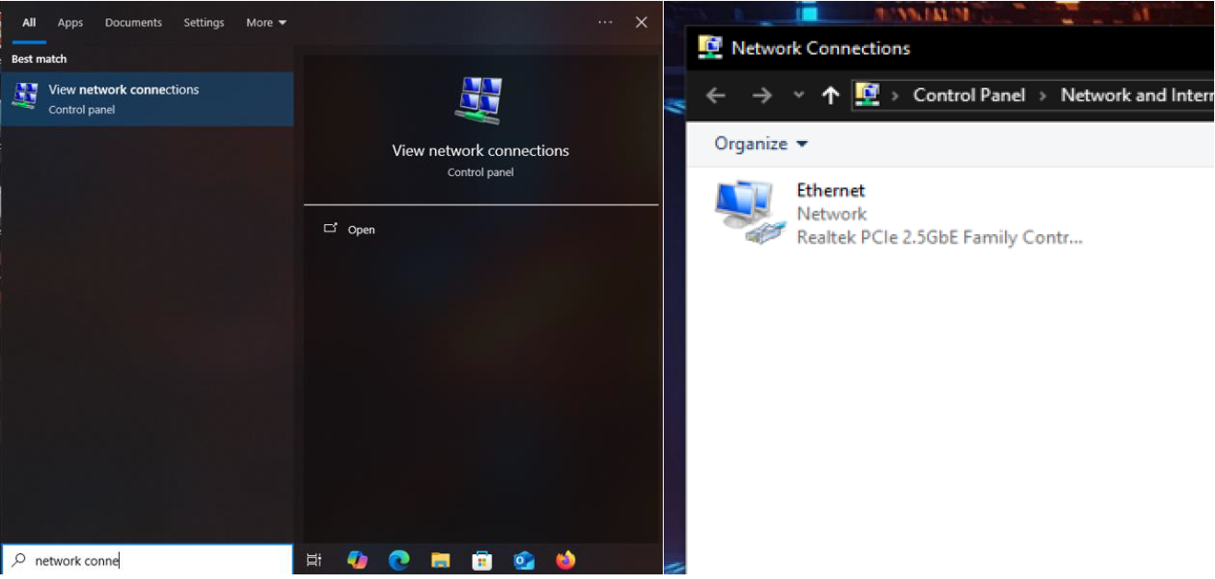Click Ethernet.

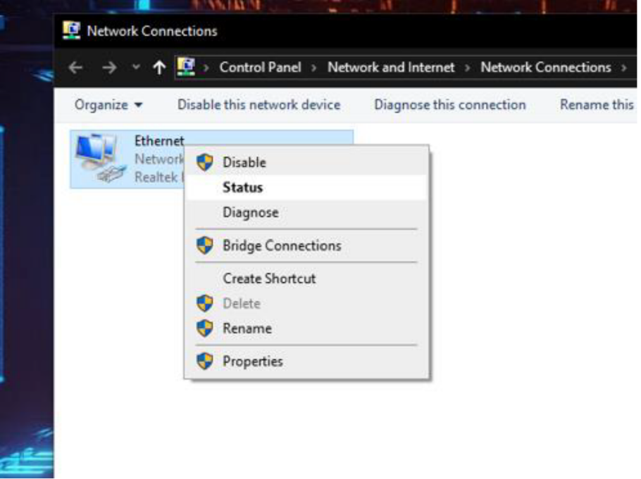

We need to Note the iP

**Part 1: Installing the Windows FTP Server Software**

1. 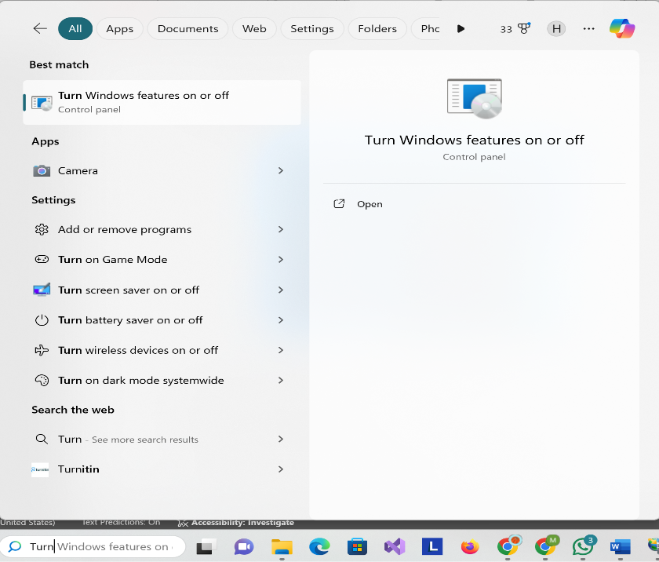Open the Windows Features menu**.**
2. Click the + next to "Internet Information Services.
3. Check the "FTP Server" box.
4. Click the + next to "FTP Server.
5. Check both the "FTP Extensibility" and "FTP Service" boxes.
6. Check the "Web Management Tools" box.

1. Click OK.
2. Click Close when prompted.

**Part 2: Creating an FTP Server**

1. Create a new folder for your files.

1. 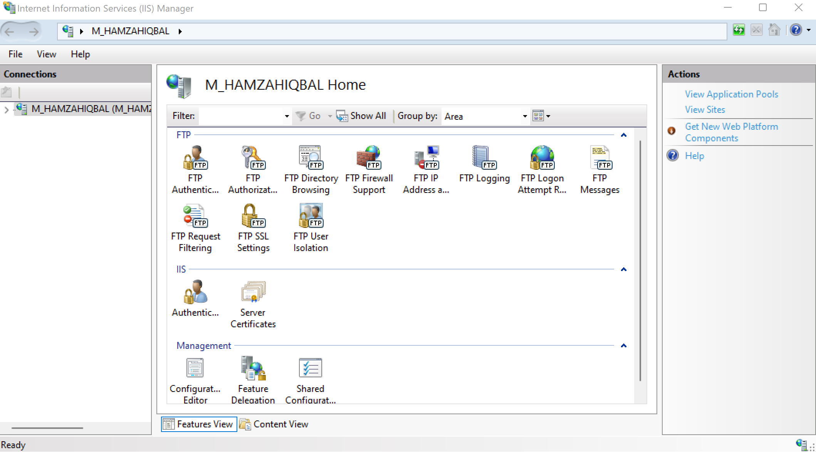Open the IIS Manager**.**
2. Click the arrow next to your computer's name
3. Right-click Sites in the left panel. A context menu will appear.
4. Click Add FTP Site… on the menu.

1. Type a name for your FTP server into the "FTP site name" field.
2. Select the FTP folder you created.
3. Click Next.

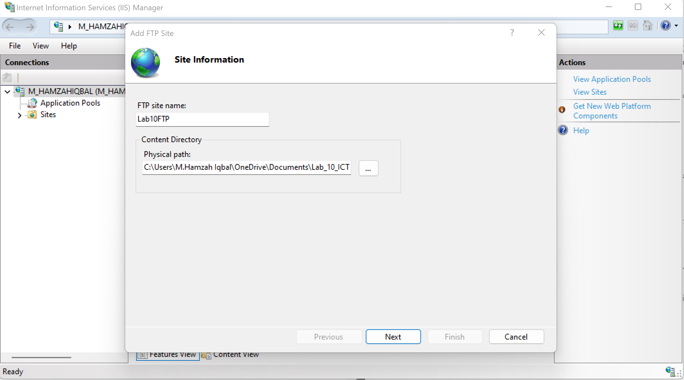

1. Enter the IP address for the server computer.
2. Check the "No SSL" box if you won't be allowing connections from outside of the network.
3. Click Next. This is at the bottom of the page.

1. Select who can connect to the FTP server.
2. A screenshot of a computer

   Description automatically generatedClick the Finish button.

**Part 3: Allowing FTP through the Windows Firewall**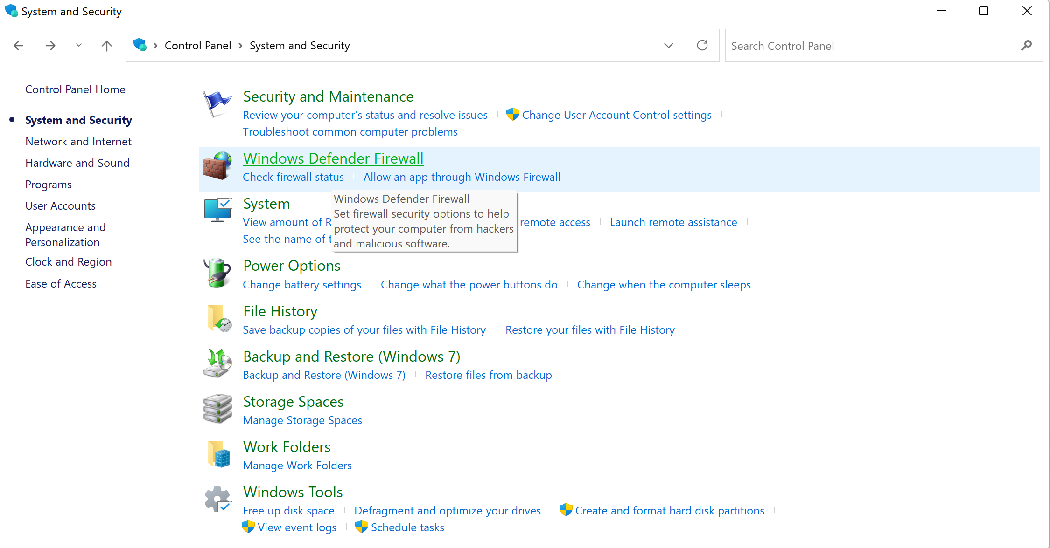

1. Open the "Allowed Apps" Firewall page.

1. Click the Change settings button.
2. Scroll down to the "FTP Server" option.
3. 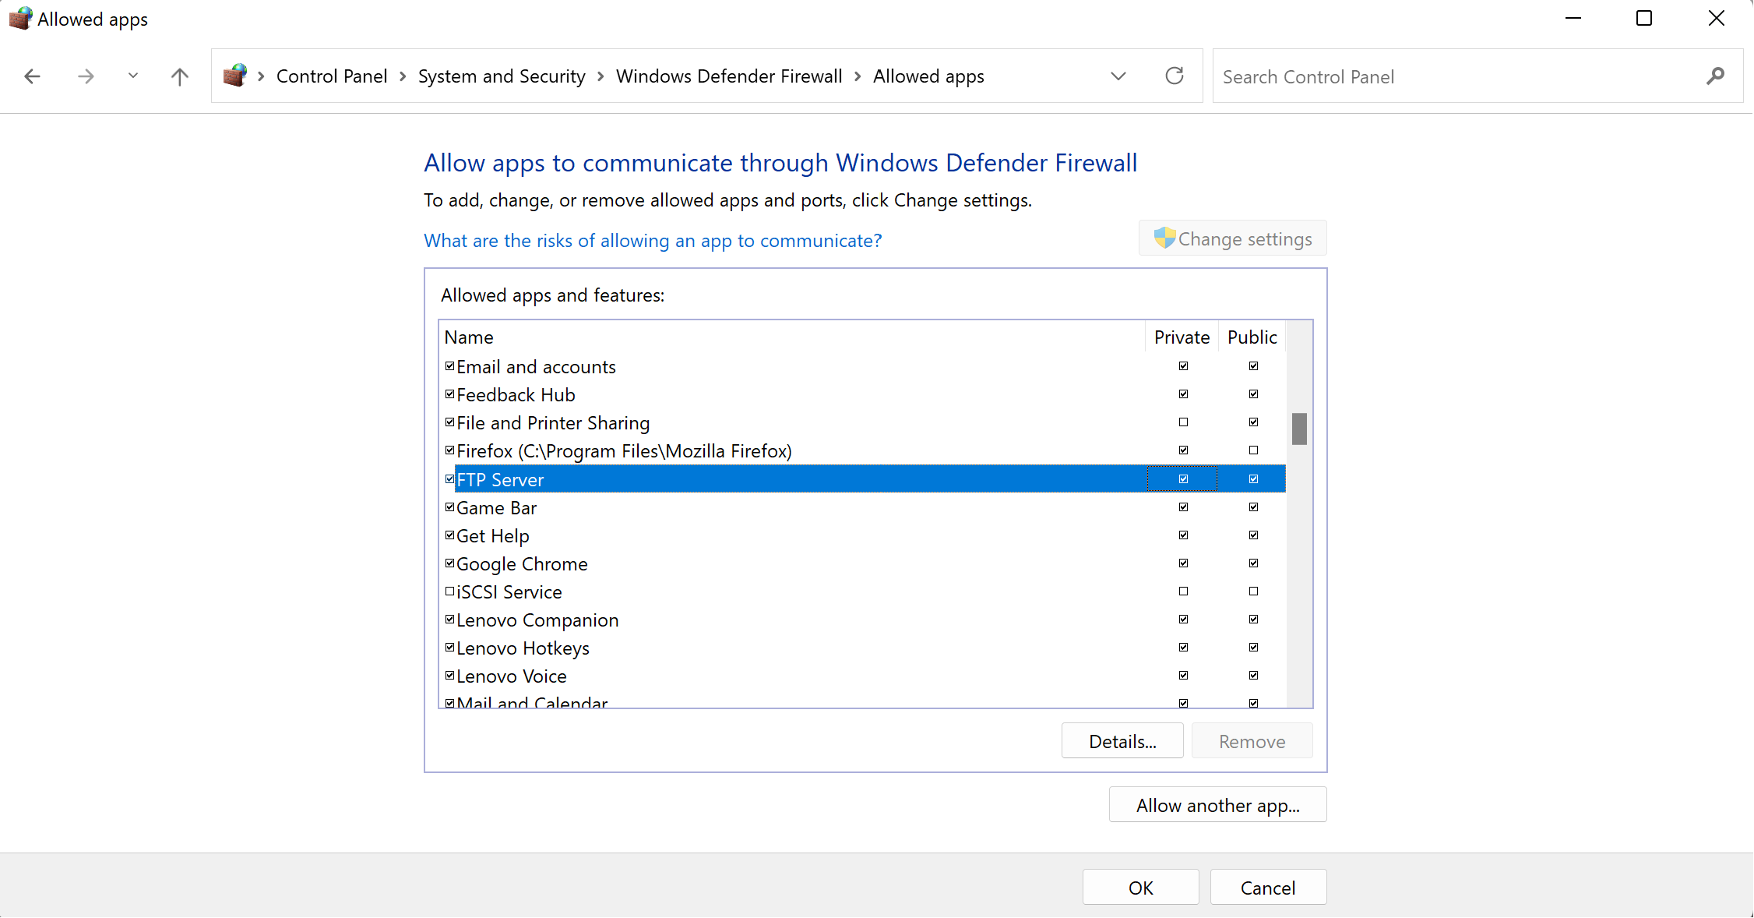Check all three "FTP Server" boxes.
4. Click OK.

**Part 4: Connecting to the FTP Server**

1. Determine the FTP server's IP address.

* Static IP of the Ftp Server was configured.

1. 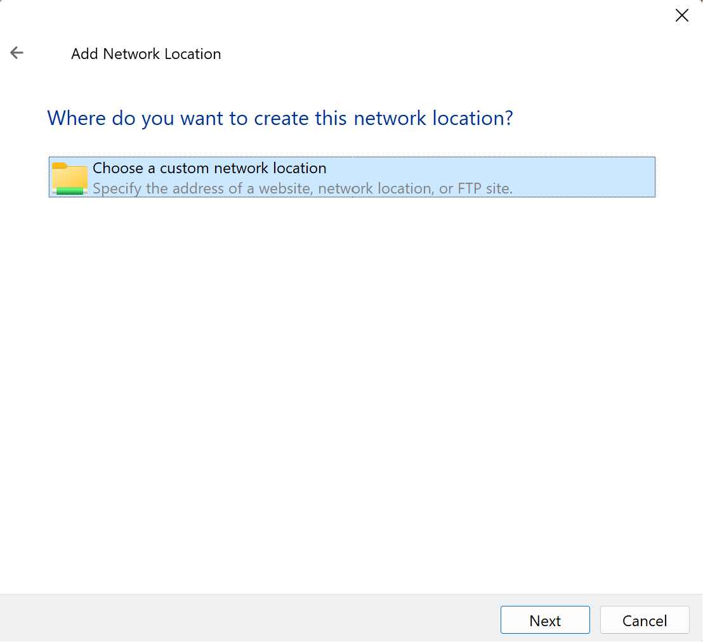Open a web browser on the other computer.
2. Enter your FTP address and press Enter.

1. Sign into the FTP server.

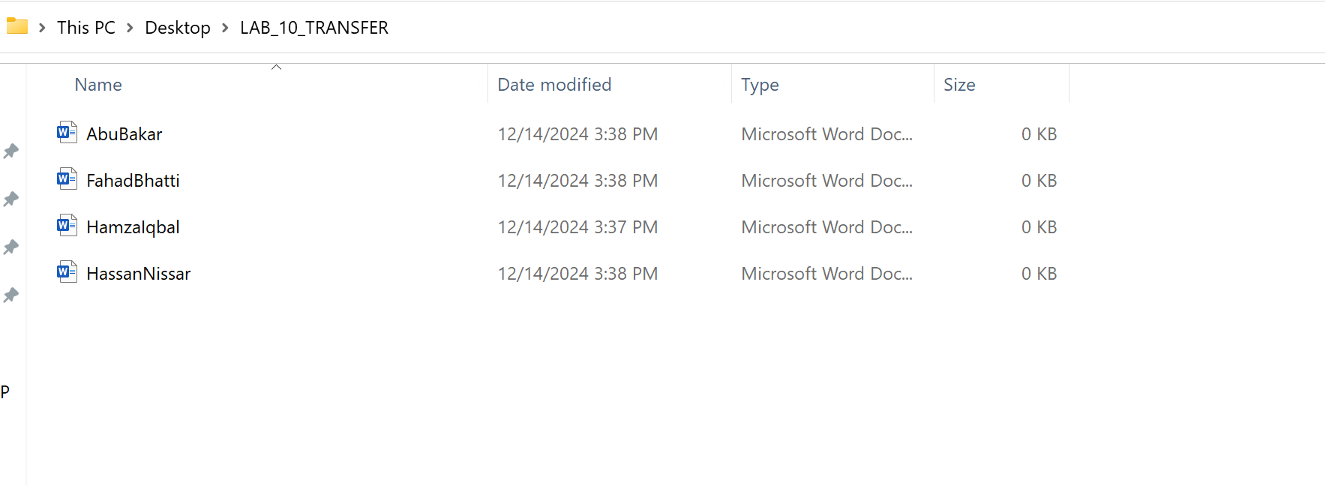**Transferring files**:

**Conclusion:**

An FTP server is a software application that allows users to transfer files over a network using the File Transfer Protocol. It acts as a centralized storage point, enabling multiple users to access and share files securely. Here’s why FTP servers are so useful:

* **File Sharing:** FTP servers facilitate easy and fast sharing of files between computers, eliminating the need for physical storage devices.
* **Backup and Storage:** Businesses use FTP servers to store critical data and perform regular backups.
* **Remote Access:** Users can access files stored on an FTP server from anywhere, provided they have the credentials.
* **Large File Transfers:** Unlike email or instant messaging, FTP servers can handle large file sizes efficiently.

By setting up an FTP server, you enhance collaboration and streamline data management in both personal and professional environments.

In this lab, we explored the foundational concepts of networking and implemented an FTP server to transfer files efficiently. FTP servers are indispensable tools in modern computing, providing a robust solution for file sharing, remote access, and data storage. By mastering these basics, you’re well-equipped to tackle more advanced networking concepts and applications. Understanding how to set up and use an FTP server is a valuable skill that bridges the gap between theoretical knowledge and practical implementation.